

**FUNDAMENTALS OF BUSINESS ANALYSIS**

**(5 TECHNIQUES)**

**GROUP 5**

**Sandeep Pulavazhy - Prototyping**

**Vitalijs Kaniscevs - Financial Analysis**

**Kristians Bogdanovs - Document Analysis**

**Arnas Karciauskas -Requiement Workshop**

**Mark Redmond - Observations**

**PROTOTYPING**

**PURPOSE:**

Prototyping is a technique used to include stakeholders needs through several processes that will create an interactive word and design. That means in prototyping technique a mock model of the product is created so that the stakeholders will get the clear idea of how the final product looks like. Prototyping technique is really useful in creating a partially working website or by describing the process to reach the final output through a diagram such as workflow, flowchart etc... These diagrams can be used for data cleansing and also helpful to show the data transformation. Prototyping is considered as the proven technique for product design.

**DETAILED:**

There are two approaches to prototyping.

They are:

→ Throw-away prototyping

→Functional prototyping

**Throw-away Prototyping:**

These kinds of prototypes are created by using pen, paper, pencil or any kind of small software in order to cover the requirements for the projects. Throw-away prototypes can be updated or can undergo any kind of changes during the project development. They are also useful in figuring out the processes that are not easily figured out by other business techniques. Generally, throw-away prototypes are not expensive.

**Functional Prototyping:**

Prototypes are designed to extend the initial requirements into functioning solutions are the solutions are through the stakeholders. This prototyping need a specialized working tool or software**.** Functional prototyping helps the stake holders understand how the final product look like. This will help them to understand what all new features added in the new design and how they work. The feedback for the work is given faster because the working model of the project helps in identify the features and the problems fasters so that the stake holders can note them and give the feedback.

**PROTYPING METHODS:**

There are 4 types of prototyping methods:

They are:

→storyboarding

→paper prototyping

→workflow modelling

→ simulation

**Storyboarding:**

Storyboarding is a kind of design that uses sketches or pictures to demonstrate the final result or output to the users or stakeholders.

**Paper Prototyping:**

The word itself says how this prototype is created. This prototype is created by using a pen and paper to describe how the process undergoes to in order to get the final result.

**workflow modelling**:

This is the visual representation of the flow of work. This visual representation (visual diagram) will help to find out the flow of work process.

**Simulation:**

Simulation is a kind of digital prototype that will help the designers to find out how a single part could fail and how to fix it.

**JUSTIFICATION:**

Prototypes are the proven technique for designing a product. Prototypes will help the designers to get a clear idea of how the final result should look like so that they can work accordingly. The reason for selecting prototype is they are generally less expensive. They can be applied where cost management is factor. Users have an important role in prototype technique because the requirements are completely based on user. Since prototype provides a working model of the system, users will get a clear idea about how the system is being developed. Errors can be easily detected as compared to other techniques.

If a project needs more feedback and recommendations from the user, prototyping is the best elicitation technique that can be used. Since NCI websites needs a lot of interaction with the end user, the prototyping technique is the best option. Because Prototyping model should be used where the system requires an interaction with the user.

**WORK BREAKDOWN:**

As per the rules , the project was breakdown into many parts. This breakdown structure will help to get a clear idea of what should do in each week. This was done using software called Microsoft excel. The work breakdown for prototyping is listed below:

REFERENCES:

### Advantages & Disadvantage of Prototyping process model

**In-text:** (IOTAP Inc, 2017)

**Your Bibliography:** IOTAP Inc. (2017). *Advantages & Disadvantage of Prototyping process model*. [online] Available at: https://www.iotap.com/blog/entryid/124/advantages-disadvantage-of-prototyping-process-model [Accessed 7 Oct. 2017].

### Prototyping

**In-text:** (BABOK Page, 2017)

**Your Bibliography:** BABOK Page. (2017). *Prototyping*. [online] Available at: https://babokpage.wordpress.com/techniques/prototyping/ [Accessed 7 Oct. 2017].

**In-text:** (Anon, 2017)

**Your Bibliography:** Anon, (2017). [eBook] Available at: http://www.innovativeprojectguide.com/documents/BABOK_Guide_v3_Member.pdf [Accessed 7 Oct. 2017].

**OBSERVATIONS**

The elicitation technique that I have chosen for my Business Analysis project is Observation. Elicitation is the act of collecting requirements of a system from users, customers, and other stakeholders. Typically observation is used to gain insight about how work is done in a company currently, in different circumstances depending on the company – Babok pg 64 4.2.6.

Observation is typically used to retrieve information by viewing activities in context. It is typically used to identify needs and opportunities. When I was reading through the various different elicitation techniques observation stuck out to me as a technique that I’d like to talk about in my project due to the interesting process of job shadowing, the act of following someone around while they do their job and observing what they’re doing. There are typically 2 different ways of doing observation.

For example, the person doing the observing of the job can ask various questions as they spectate, this has some negative effects however as it may interrupt the work flow, the observer however will be able to quickly understand the reasoning and hidden processes behind the activity that the employee is doing. The other type of observation is one where the observer does not interrupt the work. Any questions are asked once the work has concluded. This allows for the natural flow of events to occur and the work to be done as normal. During observation the following can be deduced – understanding the particular activity and it’s components such as tools and interactions, identifying opportunities for improvement, establishing performance metrics and assessing solutions and validation assumptions.

* Babok Pg 306 10.31.2

From my own point of view this was the most interesting one of the various elicitation techniques that are included in Babok. I am certainly interested In learning more about this particular elicitation technique

**Project Plan**

|  |  |  |  |  |  |
| --- | --- | --- | --- | --- | --- |
| **Elicitation Title** | **From** | **To** | **Performed By:** | **Task:** | **Participants:** |
| **Documents Analysis** | **16/10/2017** | **23/10/2017** | **Kristians Bogdanovs** | **Scan the NCI website for problems/bugs, as well as unnecessary things/or improvements.** | **Sandeep, Arnas, Mark, Vit, Kristians** |
| **Documents Analysis** | **23/10/2017** | **25/10/2017** | **Kristians Bogdanovs** | **Provide a full report of the problems found on the website.** | **Sandeep, Arnas, Mark, Vit, Kristians** |
| **Documents Analysis** | **25/10/2017** | **01/11/2017** | **Kristians Bogdanovs** | **Review the report brought by the team from the previous task and record any relevant problems found on the website.** | **Kristians Bogdanovs** |
| **Documents Analysis** | **01/11/2017** | **06/11/2017** | **Kristians Bogdanovs** | **Document any questions that may have come to mind during the analysis procedure to be brought to the stakeholders later on.** | **Sandeep, Arnas, Mark, Vit, Kristians** |
| **Documents Analysis** | **06/11/2017** | **10/11/2017** | **Kristians Bogdanovs** | **Arrange meetings with stakeholders to revise the notes provided earlier, arranging requirements, and answering questions brought up in the previous task.** | **Sandeep, Arnas, Mark, Vit, Kristians** |
| **Documents Analysis** | **11/11/2017** | **N/A** | **Kristians Bogdanovs** | **Provide gathered data to serve as a basis for executing other elicitation techniques, such as prototyping.** | **Kristians Bogdanovs** |
| Prototyping | 16/10/2017 | 23/10/2017 | Sandeep pulavazhy | Undentifying the problem | Sandeep, Arnas, Mark, Vit, Kristians |
| Prototyping | 23/10/2017 | 30/10/2017 | Sandeep pulavazhy | Provide a report about the problems | Sandeep, Arnas, Mark, Vit, Kristians |
| Prototyping | 30/10/2017 | 06/11/2017 | Sandeep pulavazhy | Create a priliminary design of the website | Sandeep pulavazhy |
| Prototyping | 06/11/2017 | 13/11/2017 | Sandeep pulavazhy | Document the features of the new design | Sandeep pulavazhy |
| Prototyping | 14/10/2017 | 16/11/2107 | Sandeep pulavazhy | Arrange ameeting with stakeholder to discuss the new design of the website and the problems identifyied through analysis | Sandeep pulavazhy |
| Prototyping | 17/11/2017 | 20/11/2017 | Sandeep pulavazhy | Redesign the website that all can agree on | Sandeep pulavazhy |
| Prototyping | 25/11/2017 | 28/12/2017 | Sandeep pulavazhy | Arrange a meeting with stakeholder | Sandeep pulavazhy |
| Prototyping | 29/12/2017 | 4/12/2017 | Sandeep pulavazhy | Gather some information from other techinique as well to provide a full detailed design and document all and submit as a suggestion to developers | Sandeep pulavazhy |
| Observation | 14/10/2017 | 21/10/2107 | Mark Redmond | A specific list of the objectives for the observation excercise must be first drawn up and refined. Ex: Understanding the activity, understanding where imrpovement can be made etc | Sandeep, Arnas, Mark, Vit, Kristians |
| Observation | 22/10/2017 | 28/10/2017 | Mark Redmond | The second step that needs to be conducted is the preparation for observation, the objective list must be used to plan the observation and it must be decided who observes who doing what activies at a particular time. The skill and experience levels must be considered when conducting this stage | Mark Redmond |
| Observation | 28/10/2017 | 05/11/2017 | Mark Redmond | The following step is to conduct the observation session, the reasoning for the session must be explained to the participants. They may be informed that the session can be stopped at any time. The participant must be attentively watched to see the steps they follow to complete particular tasks | Mark Redmond |
|  |  |  |  |  |  |
| Observation | 06/11/2017 | 11/11/2017 | Mark Redmond | The final step is confirming and presenting the results of the excercise. Buisness analysists typically look over the notes and information recieved and follow up on the participant to get answers. | Mark Redmond |
| Observation | 11/11/2017 | 12/11/2017 |  | The notes and data are collated during this step and various trends are typically discovered. This helps identify room for improvement in the work place. | Mark Redmond |
| Workshop | 16/10/2017 | 24/10/2017 | Arnas Karciauskas | Prepare for the workshop. Identify all the requirements needed for a workshop to take place. Work with other team members to identify the requirements. Create the agenda. | Sandeep, Arnas, Mark, Vitalijs, Kristians |
| Workshop | 23/10/2017 | 30/10/2017 | Arnas Karciauskas | Assign the roles for the workshop. All workshop patricipants need to be identified and assigned their role before the workshop takes place. | Sandeep, Arnas, Mark, Vitalijs, Kristians |
| Workshop | 30/10/2017 | 03/11/2017 | Arnas Karciauskas | Send the agenda to all the patricipants before the workshop takes place. | Arnas Karciauskas |
| Workshop | 06/11/2017 | 10/11/2017 | Arnas Karciauskas | Conduct the workshop. Make sure that all the requirements are met before the workshop takes place as it is essential in order for the workshop to be successful | Sandeep, Arnas, Mark, Vitalijs, Kristians |
| Workshop | 13/11/2017 | 17/11/2017 | Arnas Karciauskas | Follow up on the workshop. Review the records and inform the patricipants of the results of the workshop. | Sandeep, Arnas, Mark, Vitalijs, Kristians |
| **Financial analysis** | 09/10/2017 | 12/10/2017 | Vitalijs Kaniscevs | Identify the problems of the current version of the website | Sandeep, Arnas, Mark, Vit, Kristians |
| **Financial analysis** | 13/10/2017 | 15/10/2017 | Vitalijs Kaniscevs | Provide a report of identified problems | Sandeep, Arnas, Mark, Vitalijs, Kristians |
| **Financial analysis** | 16/10/2017 | 22/10/2017 | Vitalijs Kaniscevs | Determine the technical characteristics of the means involved in creating and maintaining an old version of the website | Vitalijs,Kristians |
| **Financial analysis** | 23/10/2017 | 25/10/2017 | Vitalijs Kaniscevs | Identify the financial expences of developing and maintaining the current website | Vitalijs |
| **Financial analysis** | 26/10/2017 | 28/10/2017 | Vitalijs Kaniscevs | Provide a report about financial expences of the current version | Vitalijs |
| **Financial analysis** | 29/10/2017 | 04/11/2017 | Vitalijs Kaniscevs | Receive a priliminary design of the web-site | Sandeep,Vitalijs |
| **Financial analysis** | 05/11/2017 | 11/11/2017 | Vitalijs Kaniscevs | Determine the technical characteristics of the means involved in creating and maintaining a new version of the website | Sandeep, Arnas, Mark, Vitalijs, Kristians |
| **Financial analysis** | 12/11/2017 | 18/11/2017 | Vitalijs Kaniscevs | Calculate the costs associated with the development and maintenance of a new version of the web site | Vitalijs |
| **Financial analysis** | 19/11/2017 | 21/11/2017 | Vitalijs Kaniscevs | Provide a report on the estimated costs | Sandeep, Arnas, Mark, Vitalijs, Kristians |
| **Financial analysis** | 22/11/2017 | 28/11/2017 | Vitalijs Kaniscevs | Arrange a meeting with stakeholders | Sandeep, Arnas, Mark, Vitalijs, Kristians |

**PROBLEM ANALYSIS**

1. NCI college website needs to be more attractive such a providing more videos regarding the college. The responses from College Alumni. So that those who are looking for Feedback about college doesn’t need find any other source. Every information should be available on NCI website.
2. NCI Website should provide a facility where students will be able to track their attendance for each module. This will be really helpful for students to get a clear idea about their attendance. If the attendance is below 40 % then student should be notified. A good Attendance tracker facility on website will help the students to get an aware about their attendance.
3. NCI website should focus on the providing contact numbers for each department on website. So that those who want to contact particular Department can call directly without contacting the college reception.
4. While went through the website it is evident that for international students [Those who are registered] cannot request any letter through online. For example, such as requesting letter for visa, re-entry visa and so on. This will help the students that they don’t need to miss their class to apply or to collect these letters. (**sandeep pulavazhy 1-4**)
5. It is currently very hard to understand, when contacting a department in college for a specific question or query, as to which department should you be contacting in which case. While reviewing the website I saw no clear explanation of what each office does, only a list of department names.
6. Emphasising on the above, when you actually find out which department to contact and fill out the contact form, it doesn’t show any confirmation that the form has been sent to the department of choice. A user SHOULD receive both, an error message, or a successful submission message. Without the confirmation, a user may be without knowledge if their query has been received by the department.
7. Obtaining information on the timetable can be tricky. When trying to find out the student timetable, you are prompted to choose from many separate basic lists to make sure you have got the right timetable, which includes; Selecting a programme, selecting a week Range, and Selecting a Day range. After you have selected your course, it doesn’t matter what you choose, it shows the same timetable. This may create confusion and is unnecessary. When clicking on “View Timetable” button, it opens a PDF type timetable in a pop-up. Most modern browsers block pop-up’s as it may be mistaken for an ad. Posting timetable on each modules Moodle page would be way better and easier to view.
8. When accessing Moodle, it first links to the MS Live log-in. You are then prompted to log in with your domain name (@moodle.ncirl.ie); this will bring you to NCI’s Moodle where you will be asked to log-in again. This is frustrating as to access one thing, and service students use daily, you have to log in twice. Potential solution is to bookmark the direct link to NCI’s Moodle, but this means logging into your browser every time you want to access the bookmark. (**Kristians Bogdanovs 5-8**)
9. The website represents a rather boring style of pages, more like an online book with a small number of images and text on a white background. The main page is framed seemingly inexpressibly, when choosing an educational institution and visually does not attract attention.
10. Excessive number of pages, with a lot of information and links, which do not always have a related logical structure.
11. Multiple levels of access to site resources (separate Moodle, separate Virtual Desktop, Exam results and other). It is more reasonable to make one Log In and then free access to all resources.
12. Using different Log-In formats for different resources (full domain name, short domain names) is the reason for failed log-in attempts. (**Vitalijs Kaniscevs 9-12**)
13. One of the biggest issues that I have found on the NCI website is the fact that a lot of the information is spread out in tabs and sub-tabs across the website. I believe that this information could be a lot more compact, making it a lot easier to find and access.
14. Another issue that I found with the NCI website is the lack of an online payment facility, when paying for things such as exam repeats or even college student's union events you have to go into the college and pay with either physical money for event tickets, or write out your card details for exam repeat fees (which doesn't even accept physical money anymore).
15. One more issue that I believe should be looked into is the Timetable function on the NCI website, when trying to find your timetable on the website it presents a list of options which you are required to select, such as department, programme etc. I believe that the amount of options is incredibly inaccessible and can be changed in a way that it is easy and quick for a particular student to get the timetable for their course.
16. The final issue that I found was a big problem with the lack of visual representation of the college on the website, I believe that more pictures could certainly be implemented as a way of showing off the quite visually appeasing college campus. (**Mark Redmond 13-16**)

We need to send out e-mails to all the stakeholders asking them to participate in the workshop. We need to do it as soon as possible so that they have enough time to prepare.

E-mails need to be sent to the student’s union members, class representatives, director of NCI, lecturers, IT department and administration.

During the workshop, we will need to ask the participants questions regarding the current NCI website. We will ask all participants specific questions which will be decided until next week, questions will need to be sent to the stakeholders 1 week before the workshop takes place. We will try to make sure everyone shares their opinion as this will give us the best insight. The goal of the workshop will be to get a good insight of what is needed to improve the NCI website, cost and feasibility. This information will help us create a plan, execute it and make sure, that everyone is satisfied with it. It will be very useful because many companies do not ask their stakeholder’s opinions and make changes without consulting the relevant stakeholders first which usually results in more costs and time. We want to get as many stakeholders as possible as this will give us a better insight from different perspectives.

We have decided on the roles for our team for the workshop:

Sandeep – will be the facilitator because he has the most experience in communicating individually and with groups of people.

Arnas – will be the business analyst and will analyse the results of the workshop after the

workshop has taken place and will also be responsible for inviting all the stakeholders.

Vitalijs – will be responsible for finding a suitable room in the NCI with the required equipment

for the meeting, microphone, whiteboard, projector.

Kris – will send the agenda and all the relevant materials 1 week before the workshop is scheduled to take place as this will allow enough time for the stakeholders to prepare, this will give us a better chance of having a successful workshop.

Mark – will manage time during the meeting and make sure that the meeting does not lose its track.

(**Arnas karciauskas**)

WIREFRAMING:

The aim of this project was to provide a preliminary design of the NCI website. As per the information provided on the excel sheet by our group members, I have to provide a preliminary design of NCI website. Providing a preliminary design of the website helps the stakeholders to have a look on the website and go through the new facilities introduced through college website.

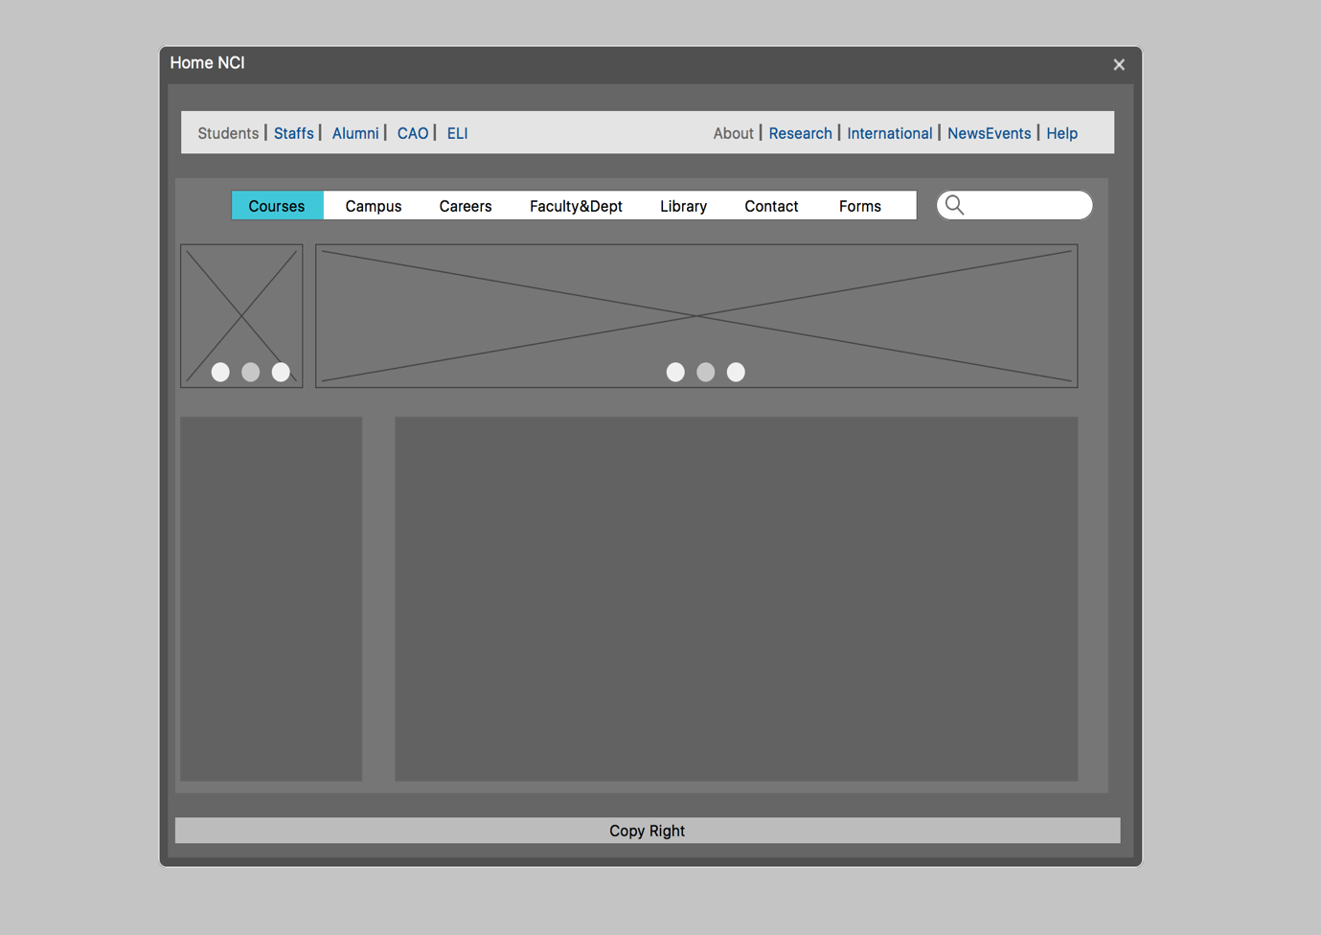

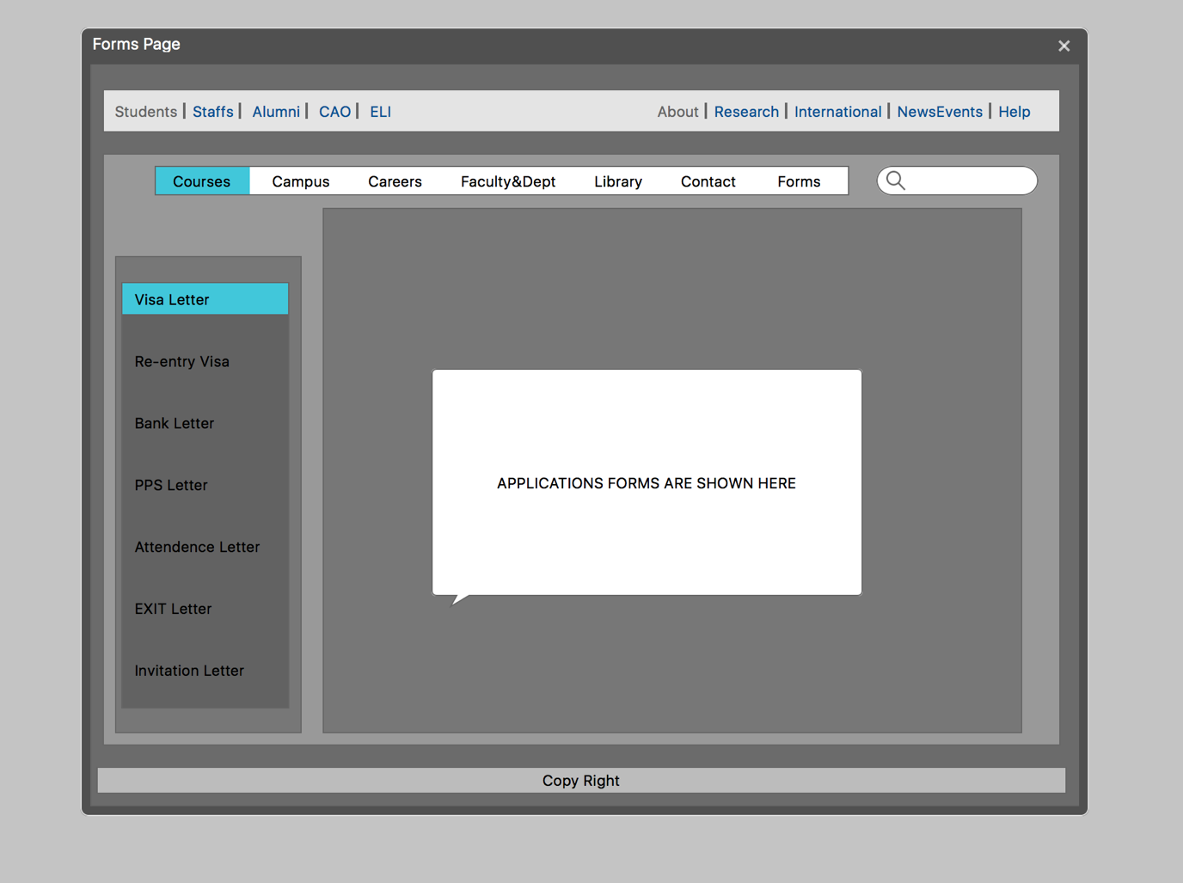

The wire framing for the website was done using an application called Mock Plus. This application will help to give a working model of the website.

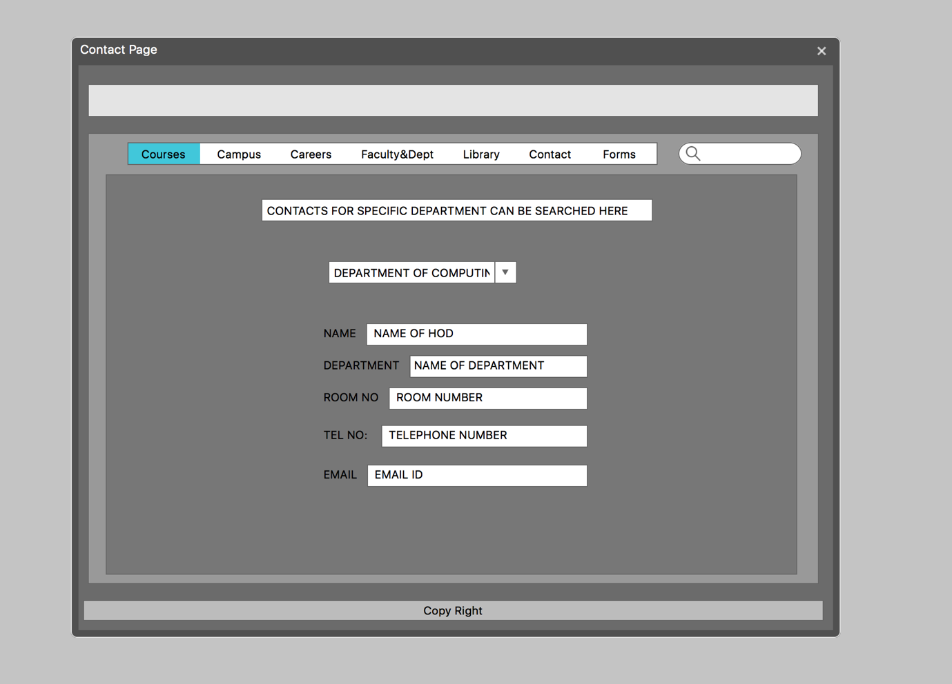

**FEATURES OF THIS NEW DESIGN:**

A wireframe is created for three pages. The first page was HOME page, the second one was a new page called FORMS, and then the third one called contact page. The Home page contains main menus and the links for the other pages. There is a space for adding images and videos to the page. So that those who want to have more information about college can have look at those videos. List of courses available and the fees for those particular courses should include in home page. The second one was called FROMS. As we know that NCI contain many International Students, the website should contain new feature called FORMS. In this page the students can search for any letters that are available from International Office. Students can select the application forms from the side bar,; then that particular application form is displayed on the website. Students can fill in that form online and can submit it to through online. This will directly go to the international office. This feature can save a lot of time for NCI students. The next feature is CONTACT page. NCI Website don’t have a detailed contact page. It is not possible to search to get the contact information of particular person[HOD]. It is not possible to contact HOD or lectures through phone. This wireframe provides new page called CONTACT page where Students can search contact information for HODs or lectures they are looking for. Students just need to select which department they are looking for, then the name of HOD, Room number, Telephone number and the email id will be displayed on the website. The Colour schemes used here are the shades of grey.

Observation Benefits

Observation is a very important elicitation technique when it comes to acquiring information about how a group of workers acts in a working environment, it being in a group setting or solo work.. Wheater that be a program, a website or an application. It is particular good at gathering information about how work is done in various different places and under different circumstances.

IIBA, 2015, BABOK:V3 ,Toronto: International Institute of Business Analysis. Page 306 Observation

Steps when it comes to Observation in a work environment

As with a vast majority of elicitation techniques, the first step when it comes to observation is the preparation stage. Preparing for Observation requires a variety of different steps. It involves planning for the approach based on any particular objectives you have for the observation session. One of the biggest things that has to be considered when preparing is the skill and experience levels of the individual participants in the observation setting, expecting an amateur programmer to perform at the level of an advanced programmer for example, would simply ruin the observation session as the data that you collect may be incorrect. Another thing that is incredibly important when it comes to the planning phase of observation is to create a schedule of observations, and decide which person to observe at a particular time on a particular day. The planning phase ensures that all the stakeholders are aware of the function of the Observation Session, they agree on the outcome and the session is what they expected.

IIBA, 2015, BABOK:V3 ,Toronto: International Institute of Business Analysis. Page 306 Observation

Conducting the Observation Session

After the planning phase before the observation session a variety of different things must also be performed. The participants of the session must be briefed on the session and the schedule must be explained. The participants must be assured that their work is not being judged individually but rather along with the work of their fellow employees, as a whole. The participants must be informed that the observation can be stopped at any point if they get under too much pressure.

During the observation session yet again, a few things must be done, first of all the person must be observed attentively as they perform the particular piece of work. Typical tasks should be noted, as well as what tools are used. Everything seen must be recorded, as well as the time that certain tasks take to perform. A variety of questions should be asked throughout the session referring to the way a particular employee or group of employees perform a certain activity.

IIBA, 2015, BABOK:V3 ,Toronto: International Institute of Business Analysis. Page 306 Observation

Presenting the Results

When the observation session has been concluded, the analyst should go over the notes and data obtained from the session, and follow up with the participant and ask follow up questions referring to the session to fill in any gaps that may be left in the business analyst's knowledge.

IIBA, 2015, BABOK:V3 ,Toronto: International Institute of Business Analysis. Page 307 Observation

Strengths and Limitations

Strengths

* You can gain realistic insights regarding the activity being performed
* Incorrectly / atypically performed tasks and work arounds can be found
* Activities can be observed firsthand and compared against an established norm

Limitations

* It can be considered disruptive to the performance of the participants
* May be considered intrusive to the person being observed
* A large amount of time may be required to plan and conduct the technique

IIBA, 2015, BABOK:V3 ,Toronto: International Institute of Business Analysis. Page 307/308 Observation

ARNAS Karciauskas

x16457054

GROUP 5

REQUIREMENT WORKSHOP

Redevelopment of the National college of Ireland Website

Requirements Elicitation using Requirements Workshop

Contents

Introduction 29

Requirements Workshops 29

What is involved? 30

Why requirements workshop would be useful for redeveloping the NCI website. 31

Pros 31

Cons 32

Why I chose Requirements Workshops 32

Schedule 32

Preparing for the workshop 33

Roles for our team for the workshop: 34

Identifying the stakeholders and agenda 34

Stakeholders 34

Agenda 35

Topics: 35

References: 36

# Introduction

In this project, I will be writing about requirements workshops and how they would be applied to the redevelopment of the National College of Ireland website. We are required to complete a Requirements Elicitation using 5 different elicitation techniques. My chosen technique is Requirements Workshops which I believe is one of the most effective ways of gathering requirements for the project.

# Requirements Workshops

Requirements workshops involve multiple stakeholders from different areas of the company, they can be executives, floor staff, students or contractors or any other individuals that play a part in the company. Workshops are an effective way of eliciting the requirements for the project as it requires all the stakeholders that participate in the workshop and work together. The workshop involves an organized meeting of the stakeholders which involves discussion of the project that is planned with defined goals before the workshop takes place. The goal is to meet all the requirements by the time that the workshop is finished. Workshops are an effective way of achieving the defined goals and can be used for planning, analysis, design, scoping, requirements elicitation, modelling or any combination of these goals. Business analysts are responsible for setting up the workshop.

A workshop is useful for:

* Discovering requirements
* Refining requirements
* Prioritizing requirements
* Scoping requirements

Ref:<http://www.innovativeprojectguide.com/documents/BABOK_Guide_v3_Member.pdf> Chapter 10: Techniques, Workshops 10.50.1 to 10.50.4

## What is involved?

The workshop usually involves a facilitator and it is essential that the facilitator has an excellent insight of the project to be able to run the workshop efficiently by leading the discussion, showing initiative and asking questions that are relevant to the project. If a facilitator is not competent then the workshop will very likely be a failure. The facilitator must remain neutral during the discussion.

For a workshop to be successful a plan with predefined goals of the workshop is necessary. Before a workshop takes place, a plan identifying all the activities and the main goal of the workshop needs to be made.

The objectives of the workshop must be clear to all the stakeholders participating in the workshop. A list of topics to be discussed at the workshop should be sent to all the stakeholders that will be participating so that they will know what to expect on the day and prepare for the discussion.

It is important to get stakeholders from all areas of the project in order to be able to achieve the goals and get insight from all the different stakeholders which can provide useful information. The workshop will not succeed if half of the vital stakeholders of the project are missing. It is essential that Subject Matter Experts are present as they are knowledgeable about the area that they work in. The more varied the group the better results that you will get.

A workshop usually involves are scribe which writes down everything that is said in the workshop for review at a later date.

Workshops are effective because they:

* Achieve a predefined goal in a single workshop.
* Makes stakeholders of the project work together to achieve a mutual goal
* The cost is low compared with other methods.
* Feedback is provided by stakeholders form various areas of the company and Subject Matter Experts.

Ref:<http://www.innovativeprojectguide.com/documents/BABOK_Guide_v3_Member.pdf> Chapter 10: Techniques, Workshops 10.50.1 to 10.50.4

## Why requirements workshop would be useful for redeveloping the NCI website.

Various stakeholders would be able to participate and give their insight into the project. Student Union leaders could be asked to attend the workshop and provide insight from the students. Workshops promote communication between the stakeholders and makes them work together to achieve common goals.

Current IT staff would be asked to attend and provide information on the current situation of the website and what could be changed and make recommendations.

The lecturers could be asked to participate and provide their own insight in regards to current issues that they experience with the website.

All workshop participants would provide their insight on the current status and the expectations of the redeveloped website. Discussions would take place with all the stakeholders involved, issues would be solved and compromises made. After a workshop the stakeholders that participated would be immediately aware of the result of the workshop. Workshops are useful because the goals must be achieved in the workshop.

Having a workshop would be particularly useful regarding the NCI website as all stakeholders would have participate in the workshop. Everyone would be aware of the changes and have a chance to add to the discussion by providing their own views, feedback or concerns. Stakeholders from various knowledge areas of the NCI would have to work with each other to achieve the predefined goals.

Ref: <https://businessanalystlearnings.com/blog/2013/2/28/organizing-effective-requirements-workshops-before-during-after>

## Pros

The main pros of requirements workshops are:

* Achieving a consensus on the requirements of the project in a short period of time
* Various stakeholders involved in the project are able to participate in the discussion and share their views and make decisions.
* Low cost
* Decisions can be made straight after the workshops
* There is a record of the meeting written by the scribe and can be looked back at a later stage if any questions arise.

Ref: <http://www.innovativeprojectguide.com/documents/BABOK_Guide_v3_Member.pdf>

Chapter 10: Techniques, Workshops, 10.50.4

## Cons

Every elicitation technique has cons, cons of the workshops are:

* Because many stakeholders from different areas of the company are asked to participate, it is often difficult to schedule a suitable time and date for the workshop that suits everyone.
* Success depends on the knowledge of the participants.
* If too many members participate then the workshop process can be slowed down and if too few stakeholders participate then the input collected might not be enough and some requirements might be overlooked.

Ref: <http://www.innovativeprojectguide.com/documents/BABOK_Guide_v3_Member.pdf>

Chapter 10: Techniques, Workshops, 10.50.4

## Why I chose Requirements Workshops

I chose requirements workshops because it is a quick, low cost and effective way of gathering requirements for the redevelopment of the NCI website. Because of the participation of stakeholders from various areas of NCI, different perspectives can be gathered from the participants and decisions made during the workshop.

# Schedule

|  |  |  |  |  |  |
| --- | --- | --- | --- | --- | --- |
| **Elicitation Title** | **From** | **To** | **Performed By:** | **Task:** | **Participants:** |
| **Workshop** | 10/16/2017 | 10/24/2017 | Arnas Karciauskas | Prepare for the workshop. Identify all the requirements needed for a workshop to take place. Work with other team members to identify the requirements. Create the agenda. | Sandeep, Arnas, Mark, Vitalijs, Kristians |
| **Workshop** | 10/23/2017 | 10/30/2017 | Arnas Karciauskas | Assign the roles for the workshop. All workshop participants need to be identified and assigned their role before the workshop takes place. | Sandeep, Arnas, Mark, Vitalijs, Kristians |
| **Workshop** | 10/30/2017 | 11/3/2017 | Arnas Karciauskas | Send the agenda to all the participants before the workshop takes place. | Arnas Karciauskas |
| **Workshop** | 11/6/2017 | 11/10/2017 | Arnas Karciauskas | Conduct the workshop. Make sure that all the requirements are met before the workshop takes place as it is essential in order for the workshop to be successful | Sandeep, Arnas, Mark, Vitalijs, Kristians |
| **Workshop** | 11/13/2017 | 11/17/2017 | Arnas Karciauskas | Follow up on the workshop. Review the records and inform the participants of the results of the workshop. | Sandeep, Arnas, Mark, Vitalijs, Kristians |

# Preparing for the workshop

We need to send out e-mails to all the stakeholders asking them to participate in the workshop, we need to do it as soon as possible so that they have enough time to prepare.

E-mails need to be sent to the student’s union members, class representatives, director of NCI, lecturers, IT department and administration.

During the workshop we will need to ask the participants questions regarding the current NCI website. We will ask all participants specific questions which will be decided until next week, questions will need to be sent to the stakeholders 1 week before the workshop takes place. We will try to make sure everyone shares their opinion as this will give us the best insight.

The goal of the workshop will be to get a good insight of what is needed to improve the NCI website, cost and feasibility. This information will help us create a plan, execute it and make sure that everyone is satisfied with it. It will be very useful because many companies do not ask their stakeholders opinions and make changes without consulting the relevant stakeholders first which usually results in more costs and time as the issues have to be fixed again at a later date which increases the cost. We want to get as many stakeholders as possible as this will give us a better insight from different perspectives.

## Roles for our team for the workshop:

Sandeep – will be the facilitator because he has the most experience in communicating individually and with groups of people.

Arnas – will be the business analyst and will analyze the results of the workshop after the workshop has taken place and will also be responsible for inviting all the stakeholders.

Vitalijs – will be responsible for finding a suitable room in the NCI with the required equipment for the meeting, microphone, whiteboard, projector.

Kris – will send the agenda and all the relevant materials 1 week before the workshop is scheduled to take place as this will allow enough time for the stakeholders to prepare, this will give us a better chance of having a successful workshop.

Mark – will manage time during the meeting and make sure that the meeting does not lose its track.

# Identifying the stakeholders and agenda

## Stakeholders

We had a meeting with our group and have decided which stakeholders should be invited to the workshop, we have decided on the following stakeholders:

NCI President

SU members

IT department

Lecturers and class representatives

Administration

We have sent an e-mail asking the stakeholders to participate in the workshop and confirm it with us, we will wait 1 week for the responses.

“Dear sir/madam

We will be conducting a requirements workshop to gather information about the changes, possibilities and requirements that are needed to improve the college website. We have chosen you as one of the essential stakeholders and would be very pleased if you would participate. The workshop will take place in the Kelly Theatre on 20/11/2017 at 11:00am, please let us know if you will be attending. If you will be participating in the workshop, we will send an agenda to you with the topics shortly.”

## Agenda

We had a meeting in which all of our group members participated and we have created an agenda.

The main goal of the workshop is to find faults with the current website, solutions and how they can be achieved. We will also get suggestions from the participants on how the website could be improved, we will ask all the stakeholders the questions outlined in the agenda.

All the participants have received an e-mail with the agenda.

The agenda includes our main goal and topics to be discussed.

The goal of the workshop is improving the current NCI website and identifying the problems with the website, finding the solutions for it and make improvements to the current one by adding/removing features, simplification etc.

### Topics:

1. Are you satisfied with the current NCI website?
2. What do you think is the biggest problem with the website?
3. What improvements could be made to the website?
4. How do you think the issues with the website could be solved?
5. Are there any features that you would like to be added or removed? Do you think the website has too much unnecessary information making it difficult to find what you need?
6. Do you think the website needs to simplified?
7. Can the requirements be accomplished?
8. Does the IT department have the necessary resources needed to redevelop the website and have the approval of the management?
9. How long the process of redeveloping the website would take?
10. Would the website users be in any way inconvenienced during the redevelopment phase?

# Workshop

We have commenced the workshop in Kelly Theatre, National College of Ireland, on 20/11/2017 at 11:00am. All the members that have sent back the confirmation for us have attended the workshop. We started the workshop with introductions and let the attendees get comfortable with each other. We have asked participants to split into groups and elect their representative, the groups were: students union, administration, IT department, lecturers and We have used a smart board and went through all the rules that we have set with the attendees which included the questions, timeframe, purpose of the workshop and the goal that we hope to achieve by the end of the workshop. Our facilitator Sandeep has started the workshop by asking the attendees to tell us if they are satisfied with the current state of the NCI website and the main flaws and positive features. The response we got was that the current NCI website has too much information and that it is hard to easily find the required information, most participants have told us that they are not satisfied with the current state of the website, except the college IT department which have told us that the current website is fine. Another thing we got from the participants is that the website is very bland and has poor visual design compared to other colleges. We have got 2 answers from the participants and have reached the consensus that there are 2 main problems which are:

1. Poor layout of the website making it difficult to find wanted information.
2. Unattractive design of the website, everything is the same bland color scheme which might put off potential students.
3. Website features not functioning properly, nci360, Moodle and citrix. This was outlined to us by members of the students union and lecturers, all of which have said that this is one of the main issues with the current website as it affects their ability to teach and study.

Our next step of the workshop is to find solutions to these problems. Again we asked our participants to do a brainstorming exercise for potential solutions to the main problems that we have found.

The answers we got from the participants were:

* Website could be simplified by removing unnecessary information, making the website smaller and easier to navigate. Instead of having multiple navigation bars, have a single simplified bar, example: courses, students, staff, contact and about. The website has significant amount of redundant headings, for example there are multiple about sections on the home page of the website, the redundant data should be removed as it clutters the website and provides no use.
* Redesign of the website, add more colors and take examples from other colleges.
* Minimize downtime of services by employing emergency staff during the weekends and evenings.

We moved forward with the agenda and asked our participants if there were any features they would like to see added to the website. We have asked each group member leader to share their thoughts and we written them on the board for everyone to see. The answers we got are as follows:

# References:

<https://businessanalystlearnings.com/blog/2013/2/28/organizing-effective-requirements-workshops-before-during-after>

<http://www.innovativeprojectguide.com/documents/BABOK_Guide_v3_Member.pdf>

Chapter 10: Techniques, Workshops 10.50.1 to 10.50.4



Document Analysis

Fundementals of business analysis

Kristians Bogdanovs | x14560287 | 2017/18

Contents

REFERENCES: 10

Advantages & Disadvantage of Prototyping process model 10

Prototyping 10

Introduction 29

Requirements Workshops 29

What is involved? 30

Why requirements workshop would be useful for redeveloping the NCI website. 31

Pros 31

Cons 32

Why I chose Requirements Workshops 32

Schedule 32

Preparing for the workshop 33

Roles for our team for the workshop: 34

Identifying the stakeholders and agenda 34

Stakeholders 34

Agenda 35

Topics: 35

References: 36

Documents Analysis – What & why? 39

How Document Analysis is performed: 39

The pros of doing Document Analysis: 39

The Cons of doing Document Analysis: 39

Why I chose to do Document Analysis for this project: 40

Revision of the Report [Ref link to report] 41

Review of the Report 41

Conclusion 42

Questions 42

# Documents Analysis – What & why?

Document analysis elicitation technique is one of the most effective ways to begin requirements elicitation phase. It means studying and revising the project background as well as identifying the opportunities for improvement. It can also serve as a method of gathering data ahead of scheduling interviews or other elicitation techniques with stakeholders.

IIBA, 2015. *BABOK®: v3: a guide to the business analysis body of knowledge*, Toronto: International Institute of Business Analysis. Page 269 *Document Analysis.*

### How Document Analysis is performed:

Document Analysis is performed in three stages, which are as follows:

#### Preparation stage

This involves finding the materials which are appropriate and applicable for the analysis as well as ensuring that the content is understandable and can be effortlessly passed on to stakeholders as required.

#### Review stage

This includes reviewing of previously found documents thoroughly and recording relevant notes to each topic that may be valuable later, noting any gaps of knowledge along the way as well as writing down any questions that arise which can later be brought to the attention of stakeholders.

#### Wrap up stage

This involves getting together with the stakeholders and carefully revising your notes, arranging requirements, and looking for answers of any questions noted during the review stage.

### The pros of doing Document Analysis:

* It can be very useful if the stakeholder is no longer with the organisation or has become unavailable
* Ensures that the analysts have more than just a blank page to start off with
* It can be used to cross check the findings of other requirements elicitation techniques.
* It can be easily accessed in the future if reviewing is required later in the project

### The Cons of doing Document Analysis:

* The analysis is limited as the documentation can be out of date or invalid
* The original author of the document may not be available for questioning should questions arise along the way
* It may end up being very time-consuming due to high volume of information which may lead to confusion

Famuyide, S. and Famuyide, S. (2017). *Understanding the Document Analysis Technique*. [online] Business Analyst Learnings. Available at: <https://businessanalystlearnings.com/ba-techniques/2013/5/17/understanding-the-document-analysis-technique> [Accessed 8 Oct. 2017].

Modernanalyst.com. (2017). *What is Document Analysis*. [online] Available at: <http://www.modernanalyst.com/Careers/InterviewQuestions/tabid/128/ID/1610/What-is-Document-Analysis.aspx> [Accessed 8 Oct. 2017].

### Why I chose to do Document Analysis for this project:

I chose to do document analysis for this project as to me it feels necessary to include this elicitation technique in the requirements phase of the project.

This technique perfectly suits our needs allowing us to research and review in detail the existing NCI website and allow us to scan for any problems that we come across as well as provide sample solutions to problems gathered by our project group.

In this project I will follow the project plan set out by the team [Reference to table]

Revision of the Report [Ref link to report]

The project team submitted a report of existing problems of the National College of Ireland website. It was evident that some of the issues needed more attention than others. Here is a full revised report:

### Review of the Report

After reviewing the report brought to me by the team, it is apparent that there are many problems in the current state of the National College of Ireland (NCI) website. I will document and describe the most relevant and important problems that occurred to me.

#### Problems

* The current website is not aesthetically pleasing and does not reflect the collage image. This needs to be addressed to the prototyping department in the next stakeholder meeting. All the information about the college MUST be available on the NCI website.
* International students have difficulty retrieving a letter from college for visa enquiries. This may cause students to miss lectures due to physically having to meet with a representative in college to receive a letter. This should be available online.
* Students may find it difficult to understand which department to contact in a specific scenario. The website does not provide any suggestions of what each department is responsible of.
* When trying to access the timetable students have to undergo several confusing and unnecessary steps. Timetable should be clear and available for easy access by the student.
* Accessing online resources for students prompts many log-ins and several different tabs which are unnecessary and unpleasant. Students should be able to log in once to avail of all services.
* The lack of ability to pay for services online, such as repeat exams. Some students may live far away, and to travel down to college to pay for a service may be rather a hassle and having the facility to pay online would be relieving.

#### Functionality

* No way of tracking your attendance: for some this is crucial as a payment may depend on the attendance percentage, which means, because student has calculated their attendance wrong they may miss a payment causing them to suffer for that particular period of time. Even though it’s the students’ own responsibility to attend class, this feature would be helpful.
* When submitting a form, there is no confirmation that the form was sent and this leaves the student guessing. This creates confusion and may lead to multiple duplicates of one query by one person.

### Conclusion

It is very evident that there are many problems with the current website. The critical listed above. The problems that the team provided were very similar and many concerning the same. During the revision process some questions arose to the stakeholders which will be documented in this report.

### Questions

Questions documented here will be brought forward to all stakeholders with the help of *Google Surveys.* The answers and any graphs or charts will be listed in this report.

1. What is the most common reason you visit the college main page?
2. Do you think that the college website is aesthetically pleasing?
3. Would you be interested in knowing your attendance through the website?
4. Have you ever had trouble understanding which department to contact in your case?
5. What is the most annoying / irritating thing about the website? Explain
6. Do you struggle to find your timetable?
7. Do you think the website lacks visual representation of the college?

<https://goo.gl/forms/iaJKlfYXFHw98WA02> Please complete the form above.

### Answers

1. What is the most common reason you visit the college main page?

* To enter Moodle, or contact college
* To find interesting news
* Moodle access
* Timetable
* Timetable

1. Do you think that the college website is aesthetically pleasing?

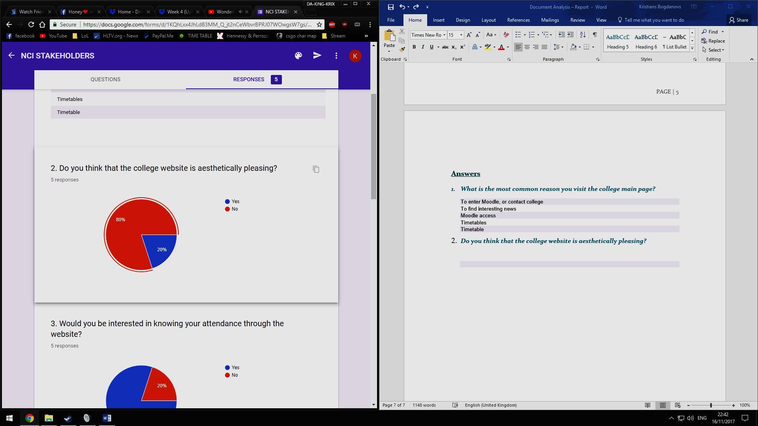

#### 3. Would you be interested in knowing your attendance through the website?

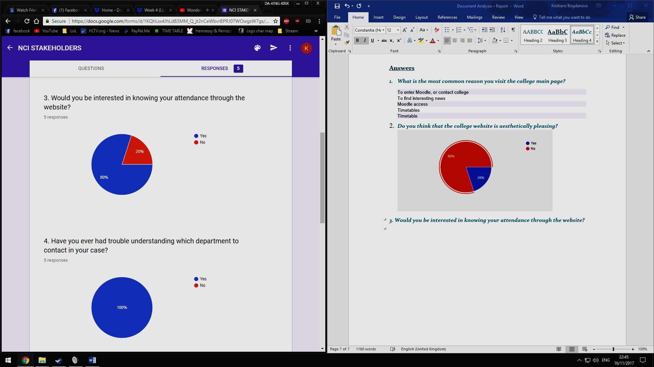

*4. Have you ever had trouble understanding which department to contact in your case?*

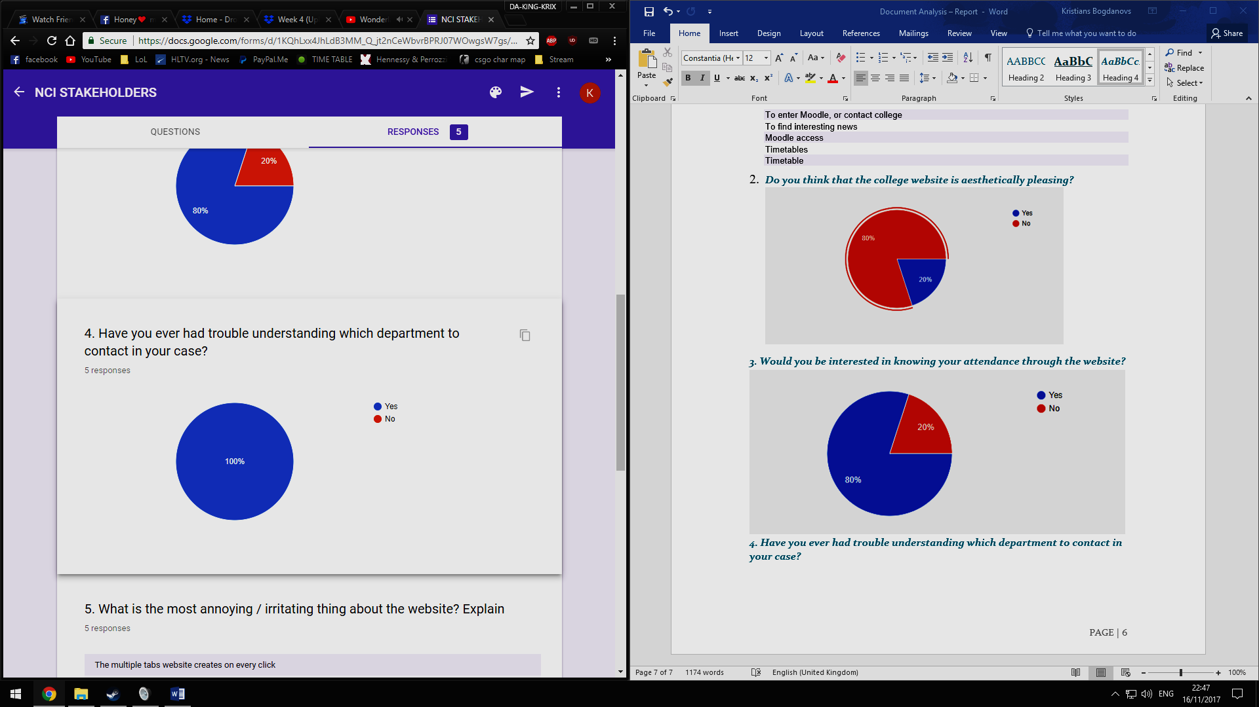

#### 5. What is the most annoying / irritating thing about the website? Explain

* The multiple tabs website creates on every click
* Lots of pages and lots of information
* No attendance tracker
* Clustered
* Too much work to get relevant information for students

#### 6. Do you struggle to find your timetable?

* Yes, way too confusing, although doable, yet unnecessary.
* It takes the time
* yes. the grid system is confusing
* Not really, maybe someone who’s less experienced with using computers would be
* Yes, too many steps to find it

#### 7. Do you think the website lacks visual representation of the college?

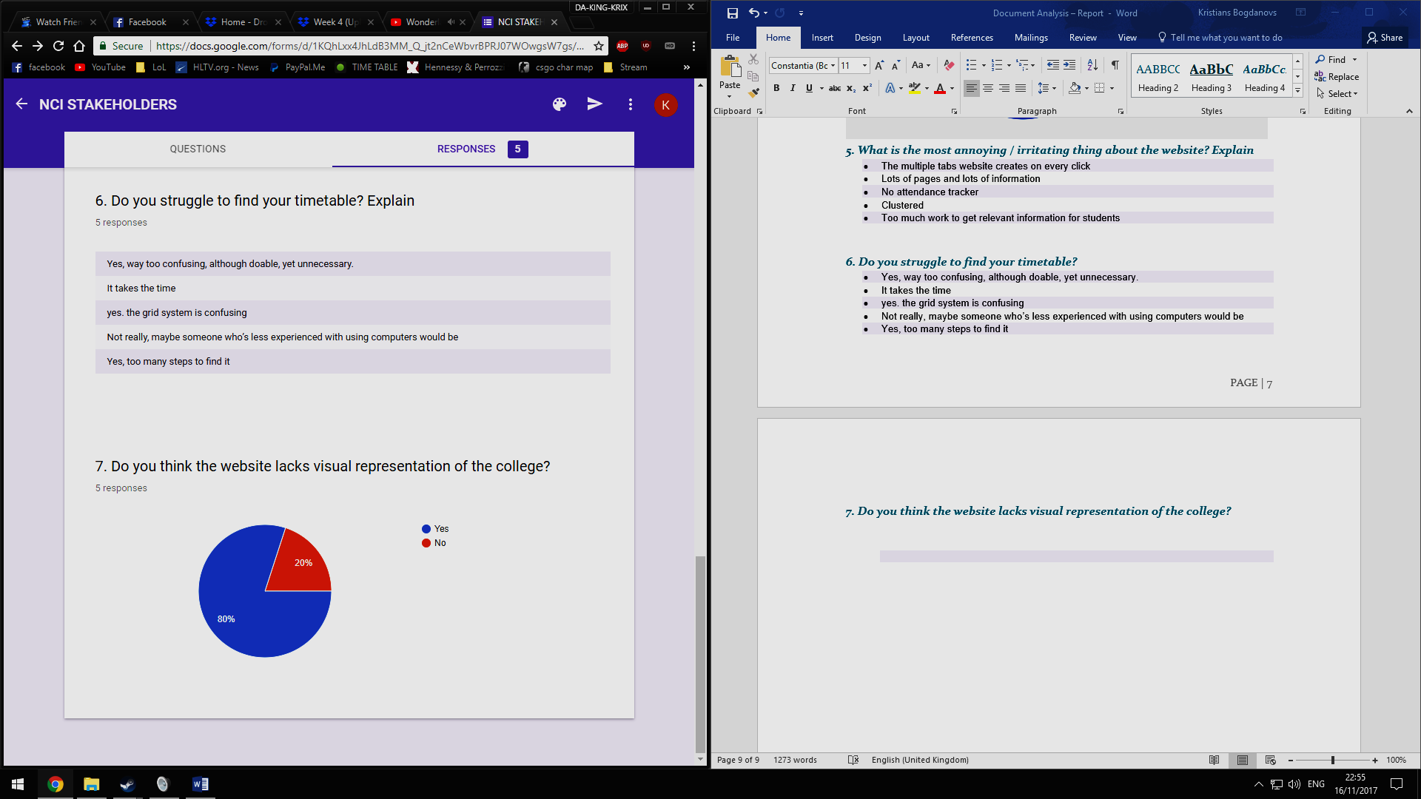

### Summary of questionnaire:

Clearly Timetable is an issue to be looked at. 40% of the correspondents said that they use the NCI website solely to view Timetables. 80% of correspondents said that they struggle finding the timetable and/or think it’s too many steps to reach their final destination.

A Staggering 80% of the correspondents answered “No” to the question: If in their opinion the college website is aesthetically pleasing. This makes you rethink the design of the website that many visit daily. To add to this, 80% answered that in their opinion the site lacks visual representation of the college. When a potentially new student looks into the NCI website, they should be ‘Wowed’ at what they see. Simply seeing a few faces of the school makes it look like a call centre website.

Adding description to school department contact pages is vital. A shocking 100% of the correspondents answered that they have at some point had trouble understanding which department to contact in your case. There are a huge number of departments in place in college. This is not necessarily a good thing, as the stakeholders that use the website most struggle to understand which department does what. A further 80% answered that they would like to know their attendance through the school website. This is accomplishable as new technology need not to be added. The college already facilitates attendance tracker via RFID cards. This information needs to be input in a real time API and output on the school website.

Confirm Elicitation Results

From conducting the Document Analysis elicitation technique, it is obvious that the website needs reconstruction. The main points are listed in the summery of survey, with the main areas being:

* Website aesthetical update
* Visual representation of college
* College departments
* Attendance tracker
* Timetables

From this it is obvious of which changes need there to be conducted.

In this section we will confirm the accuracy of the information gathered during this elicitation technique. The results will be confirmed to identify any errors before resources are committed to using this information.   
The results of this elicitation can be compared against their source, and other elicitation techniques. Some more collaboration with the stakeholders may be necessary to confirm if the results are correct. If incorrect, business analyst determines what is correct, and more elicitation may be required.

***Babok page 65.***

STAKE HOLDER MEETING PROTOTYPING

There was a meeting conducted to meet stake holders and introduce the new design for college website. The meeting was conducted in NCI college, room number 3.03. The meeting went very well. Stake holders were happy about the new features included in the college website as the students are able to fill the application forms online and send directly to the college international office. Overall, they are satisfied with the features. They noted that the website seems to be easy to handle for the users as there are no complicated and the design is sleek. The new wire framing was introduced to stakeholders using an app called mock plus. This application is used for creating a working animated wire framing, so that the stakeholders can have a look on how the website work if they approve this wire framing.

Even though they were happy about the new features included, they are not happy with the and the colour scheme that used for wire framing. They noted that the colour scheme that used for website seems to be not good. The colour scheme is depressing. So that will lead the users to have a negative thought about the college website.

In the contact page, the contact form answer boxes are unaligned. If all the answer boxes are aligned well, it will be more good looking for the website. All these are pros and cons of this prototyping model given by stake holders.

We had a discussion of another meeting to be conducted after rectifying the prototype. The next meeting was conducted on next week 28th of November at 11 am in same room. As they are only available on that time.

OBSERVATION

There are two different types of observation that may be used in regards to this particular project. Active observation and passive observation. With active observation the person is typically more noticeable, it may cause interruption to the workflow however the person observing are able to ask questions and understand the subject more throughout the process. With passive observation the observer is generally unnoticeable and usually does not interrupt the subject. Any questions are put forward once the session has ended. Video recording may also be used for passive perception. I believe that active observation is the better choice to be used in regards to the NCI website and this project as a whole, due to the fact that I'd be able to question the stakeholders throughout the process of observation. Meaning that I would learn more as the activity goes on.

When conducting observation, you should intend to completely eliminate any personal bias, Observation's based on a particular person's opinions are subjective and can easily be misinterpreted as different things can be perceived. Typically, observation should be done to collect information for quantative or statistical analysis. A good way to conduct observation is by using a wide variety of different observation tools to help in your assessment, for example a tally sheet may be used to record how often a specific event takes place. Photography and video recording can also be used while the observation session is taking place.

-Stephanie Famuyide, Using the Observation technique for requirements elicitation, Business Analyst learnings,

|  |
| --- |
| <https://businessanalystlearnings.com/ba-techniques/2013/5/16/using-the-observation-technique-for-requirements-elicitation> |

Conducting the Observation Session in regards to the NCI website

Each individual observation session should be suited to the specific requirements for the project, in regards to our Business Analysis module we're required to form a basis for the redesign of the NCI Website and Student portal. My part will be conducting the Observation session and retreiving the necessary information for the redesign of the website. Through this session and the post-session interviews we will be able to gather some more information about the issues that particular people having with using the NCI website. Through this we will also be able to retrieve suggestions from our various stakeholders on how we should improve the website. This allows for us to observe how individual stakeholders use the NCI website and allow us to make changes depending on their particular issues with the site and student portal.

**Vitalijs Kaniscevs**  **x16375211**

Financial Analysis

**Fundamentals of Business Analysis**

Content

Financial analysis as elicitation technique 1

The choice of Financial analysis-why? 1

Stages of financial analysis 1

Methods of Financial Analysis 2

Cost of a change 6

Total cost of ownership 7

Stakeholders 8

Schedule 9

Pros 9

Cons 10

Review of the Reports 10

Links 11

**Financial analysis as elicitation technique**

Financial analysis is an essential part of business analysis. The business always develops due to investments and the correct most accurate analysis is an integral part of any initiative. Any initiative should be studied by financial analysts, correctly predicted in terms of financial investments and beneficiaries, tracked at various times, studied , changed on time, if necessary. Success of investments depends From financial analysis, it helps to protect the business from financial losses and predict cash flow and return of investment.

Financial analysis is used for future investment by comparing several solutions

“Financial analysis elicitation technique is used to understand the financial aspects of an investment, a solution, or a solution approach.”: *IIBA, 2015. BABOK®: v3: a guide to the business analysis body of knowledge, International Institute of Business Analysis, Page 274, Financial Analysis;*

**The choice of Financial analysis-why?**

It is an essential part of any project. It is important for researching any investment. I chose this part so I think a financial analysis is the very important elicitation technique.

**Stages of financial analysis**

It consists of several stages:

1. Collection of necessary financial information relating to the old site

2 Processing of received financial information and receipt of settlement results.

3. Collection of the necessary financial information relating to the new version of the site.

4. Preliminary calculation of costs for site modernization

-1-

5. Approval of the cost estimate for the final version of the site.

6. Monitoring and controlling the use of funds throughout the course of the project, accounting for current and future costs.

**Methods of Financial Analysis**

In the Financial Analysis, as I mentioned above, there are 5 methods of analysis, the use of which allows you to fully reflect the financial aspects of investments and solutions for enterprises.

1.Cost of change

The cost of changes is divided into several groups, which include various elements associated with the stages of investment in the project.

1) the expected cost of the initial base costs for the acquisition of fixed assets that will be used in the project (buildings, facilities, equipment)

2) the expected cost associated with changing the properties of fixed assets (engineering changes, software changes), personnel, and other resources that may be involved in the project implementation.

*BABOK®: v3: a guide to the business analysis body of knowledge, International Institute of Business Analysis, Page 275, Financial Analysis;*

2.Total Cost of Ownership (TCO)

TCO= (Purchase Price ( asset) +  Costs of Operation).

Taking decisions about buying, buyers should look not only at the purchase price, but also at the price in the long term, which is its total cost of ownership. In the case of equipment and facilities, there is often a generally agreed to life

expectancy. However, in the case of processes and software, the life expectancy is often unknown.

Standard time period to understand the costs of ownership for processes and software is from 3 to 5 years.

-2-

*BABOK®: v3: a guide to the business analysis body of knowledge, International Institute of Business Analysis, Page 275, Financial Analysis;*

3. Value Realization

The value extracted from a process or project shown over time. The planned value can be expressed on an annual basis or cumulated over a specific period.

*BABOK®: v3: a guide to the business analysis body of knowledge, International Institute of Business Analysis, Page 275, Financial Analysis;*

4.Cost Benefit Analysis

The time period for the analysis of costs and results should be sufficient to understand that the solution is being implemented and the planned value is achieved.

*BABOK®: v3: a guide to the business analysis body of knowledge, International Institute of Business Analysis, Page 276, Financial Analysis;*

5.Financial Calculations

Why do we use financial calculations? Organizations use a combination of standard financial calculations to understand when and how different investments are beneficial.

These calculations take into account risks in investment

to the benefits obtained, with other investments that the organization

can do and the amount of time it will take to pay back.

*BABOK®: v3: a guide to the business analysis body of knowledge, International Institute of Business Analysis, Page 276, Financial Analysis;*

Consist of elements:

A.Return on Investment(ROI)

ROI determines the amount of profit or loss when investing in the project relative to the amount of investment. ROI is used to make financial decisions, to compare the profitability of an enterprise or a project, also to define the efficiency of investments. It is expressed in percentages.

-3-

ROI = (Net Profit / Cost of Investment) [x](http://www.investinganswers.com/node/6392) 100;

Net Profit = Total Benefits – Cost of Investment;

*BABOK®: v3: a guide to the business analysis body of knowledge, International Institute of Business Analysis, Page 277, Financial Analysis;*

*B.Discount rate*

Discount rate is discounting of cash flows is the reduction of the value of the flow of payments made at different points in time to the value at the current time. This is done to assess the effectiveness of investment

*C.Present Value(PV)*

PV - determines the current value of cash flows we will receive in the future.

To calculate it, the discount rate is used. The high discount rate determines the low cost of future cash flows.

PV= CF 1/(1+r)*n

CF-cashflow at period 1;r-return rate; n-period number;

*BABOK®: v3: a guide to the business analysis body of knowledge, International Institute of Business Analysis, Page 277, Financial Analysis;*

*D.Net Present Value(NPV)*

It is the difference between the Present Value of the funds received and the current value of the money spent. NPV is used to analyse the profitability of a project or investments

NVP=( Present Value(inflow) – Cost of Investment(outflow))

*BABOK®: v3: a guide to the business analysis body of knowledge, International Institute of Business Analysis, Page 278, Financial Analysis;*

-4-

*E.Internal Rate of Return(IRR)*

This is the rate of return (the discount rate) at which the net present value of the investment is zero, or that is the discount rate at which the discounted income from the project is equal to the investment costs

NPV(Net Present Value) =(-1 x Original Investment + Sum (Net benefit for relevant period) / (International Rate Return (all periods)+1) = 0.

*BABOK®: v3: a guide to the business analysis body of knowledge, International Institute of Business Analysis, Page 278, Financial Analysis;*

*F.Payback Period*

The **payback period** is the length of time required to recover the cost of an investment.

*BABOK®: v3: a guide to the business analysis body of knowledge, International Institute of Business Analysis, Page 276, Financial Analysis;*

**Using FA Methods**

All the above methods can be used completely only in cases where a certain product (product, service,) is being developed that has a finite cost and price. The sale of such a product implies the receipt of profit.

In our case, the website representing NCI is not a product that brings obvious profit. It is used for the presentation of the college and serves part of the learning process, but it is not a separate source of income. Therefore, we will use two methods of financial analysis appropriate to our situation.

-5-

**A.Cost of change**:

Below are the cost components for a website:

**Pages**(amount of pages will be build)

**Layout(**amount of page styles)

**E-mail**(amount of e-mail will be create and set up)

**Complications**

Style

Graphics design

Script ( for web-site development or rebuild)

**Options**

Logo (new or rebuild)

Upload files to system and database

Use for Mobile devices

SEO

**Social networks**

Tweeter

Facebook

LinkedIn

Blog

YouTube

I**mages**

Static gallery

Using Flickr,deviantART,Fotki,Pbase,photobucket

Dynamic gallery (slide show)

**Dynamic content**

User Profile

User Login

-6-

**Payment**

Fees

Charges

**Site management**

Domain

Email

Hosting

Advertisment(if required)

https://mazuzu.com/pricing.html#pages=0&layouts=0&complexity=0&emails=0&options=youtubeIntegration|otherIntegration

B. **Total Cost of Ownership (TCO)**

Ownership of any technology implies constant maintenance, upgrades and

expenses that may exceed the initial investment.

**Comprises**:

**Internal Cost**

Specification

Tendering

Legitimate (contract with provider)

To write a copy and provide image elements

Internal testing

Internal acceptance

**External Cost**

WEB-site design

Web-site coding

-7-

Web-site testing

Create Search engine

Training for staff

**Ongoing Cost**

Hosting

Technical maintenance

Content maintenance

Periodic maintenance

http://www.webservices.hu/default.asp?surl=?404;http://www.webservices.hu:80/tco_en/?s=default#marker_40

**Stakeholders involved in FA Elicitation Technique:**

NCI Top Manager

NCI Financial Manager

NCI Financial Department

NCI IT Support

NCI SU representative

NCI Floor staff

Legal(Web-developers)

-8-

**Schedule**



**Pros of Financial Analysis**

Allows us to accurately determine the actual costs of project of the previous periods.

Data on actual costs can be used for negotiations with web-developers.

Allows us to optimize costs according to records from accounting ledgers.

Allows us to monitor current costs and plan future costs associated with the project

-9-

*BABOK®: v3: a guide to the business analysis body of knowledge, International Institute of Business Analysis, Page 279,* Chapter 10: Techniques, Workshops, 10.50.4, *Financial Analysis;*

**Cons of Financial Analysis**

The financial analysis is more of a forecast, it will always differ from the real results and is uncertain about the expected benefits and costs.

Some costs and benefits are difficult to quantify financially.

Financial analysis covers the financial aspects of the initiative. Many other aspects that can influence the initiative are not taken into account.

**Review of the Report provided by Project team members**

The presented report of the team memeber pointed to a number of existing problems that need to be corrected. They can be divided into the following categories:

A. Interface

B. Functionality

C. Structure of the site

D. Contents

In our case, this will require costs associated with the reconstruction of only the site. This does not affect the hardware, which is already good news for management and owners of NCI, because this part is very expensive and requires a serious investment.

**-**10-

**LInks**

<http://www.innovativeprojectguide.com/documents/BABOK_Guide_v3_Member.pdf>

<http://www.investopedia.com/terms/n/npv.asp>

<https://www.thoughtco.com/discount-rate-definition-1146078>

https://www.kbc.be/corporate/en/product/financing/leasing/total-cost-of-ownership.html

<http://www.investopedia.com/terms/p/presentvalue.asp>

<http://www.webservices.hu/default.asp?surl=?404;http://www.webservices.hu:80/tco_en/?s=default#marker_40>

https://mazuzu.com/pricing.html#pages=0&layouts=0&complexity=0&emails=0&options=youtubeIntegration|otherIntegration

<https://www.myit.ie/website-design-total-cost-of-ownership-tco-really-does-matter.html>

<https://www.investopedia.com/terms/t/totalcostofownership.asp>

<https://www.websitebuilderexpert.com/how-much-should-a-website-cost/>

<http://www.webmentor.ie/how-to-guides/website-faq/28-how-much-should-a-website-cost>

<https://barn2.co.uk/wordpress-web-design/web-design-quote/>

<https://www.atilus.com/what-does-a-website-cost-web-site-development-costs/#advanced>

**Corrections And New Features for prototyping:**

There was a meeting last week the clients and the clients are satisfied with the new features added to the college website. But they are not happy with colour scheme used in the prototyping. After the meeting conducted I went through several internet sources for selecting the best colour scheme for the college website. The colour wheel of Adobe helped me to get a colour a scheme for the college website. Through some research through internet I came to know that many college website uses the colour that are used in their logo as their main colour scheme. The same colour scheme is used in NCI college website. But the way that used in the website makes the website looks not good. Instead of white background, using a high quality image of college will give a fresh look for the websites.. The background should be blurred, so that the user can get a good user experience on the website. These images will give a 3D effect for the website. According to the survey that my colleague Kristian used for document analysis it can be seen that a most students almost 80% are interested in knowing their attendance through their websites. So this feature should be added in the website. This feature was not prototyped before. Adding this feature in prototyping will help stakeholders understand more about how that works in websites. In this page students can type in their student number and can select their course they are currently studying from the dropdown list. Then their complete list of attendance will be displayed out. This new feature will help the students to keep an eye on their attendance in each class and those who have less attendance can manage their attendance for the upcoming classes.

**FINAL WIREFRAME:**

The final wireframe for the college website was created as per the needs of the stakeholders. This wireframe was introduced to the stake holders couple of days before. The meeting was conducted on 1st of December and was went well. Stake holders were happy with the latest wireframe. They said that the website looks more young as compared to that of previous one. The wireframe was created in such a way that the users can get a better user experience throughout the website. The websites uses the picture of college as the background instead of using a colour scheme. There was correction for the previous wireframe that the contact page are not well aligned. This was rectified in the new design. The new design allows the users to search for the contact person and gives you the information back in well aligned format. A new feature is also added along with this prototype. This new feature will help the students to check their attendance regularly. Stake holder were very happy about the new feature that is included in this new prototype. Students just need to type in their student number and then they need to select in which department they belong to from the drop down list that is provided. The same colour scheme is used in NCI college website. But the way that used in the website makes the website looks not good. Instead of white background, using a high quality image of college will give a fresh look for the websites.. The background should be blurred, so that the user can get a good user experience on the website. These images will give a 3D effect for the website. According to the survey that my colleague Kristian used for document analysis it can be seen that a most students almost 80% are interested in knowing their attendance through their websites. So this feature should be added in the website. This feature was not prototyped before. They are satisfied with the features. They noted that the website seems to be easy to handle for the users as there are no complicated and the design is sleek. The new wire framing was introduced to stakeholders using an app called mock plus. This application is used for creating a working animated wire framing, so that the stakeholders can have a look on how the website work if they approve this wire framing.

Even though they were happy about the new features included, they are not happy with the and the colour scheme that used for wire framing. They noted that the colour scheme that used for website seems to be not good. The colour scheme is depressing. So that will lead the users to have a negative thought about the college website.

Adding this feature in prototyping will help stakeholders understand more about how that works in websites. Overall, they are satisfied with the features. They noted that the website seems to be easy to handle for the users as there are no complicated and the design is sleek. The new wire framing was introduced to stakeholders using an app called mock plus. This application is used for creating a working animated wire framing, so that the stakeholders can have a look on how the website work if they approve this wire framing.

Even though they were happy about the new features included, they are not happy with the and the colour scheme that used for wire framing. They noted that the colour scheme that used for website seems to be not good. The colour scheme is depressing. So that will lead the users to have a negative thought about the college website.

In the contact page, the contact form answer boxes are unaligned. If all the answer boxes are aligned well, it will be more good looking for the website. All these are pros and cons of this prototyping model given by stake holders.

The Home page contains main menus and the links for the other pages. There is a space for adding images and videos to the page. So that those who want to have more information about college can have look at those videos. List of courses available and the fees for those particular courses should include in home page. The second one was called FROMS. As we know that NCI contain many International Students, the website should contain new feature called FORMS. In this page the students can search for any letters that are available from International Office. Students can select the application forms from the side bar,; then that particular application form is displayed on the website. Students can fill in that form online and can submit it to through online. This will directly go to the international office. This feature can save a lot of time for NCI students.

The screenshot of the wireframe are provided below:

MAIN PAGE:

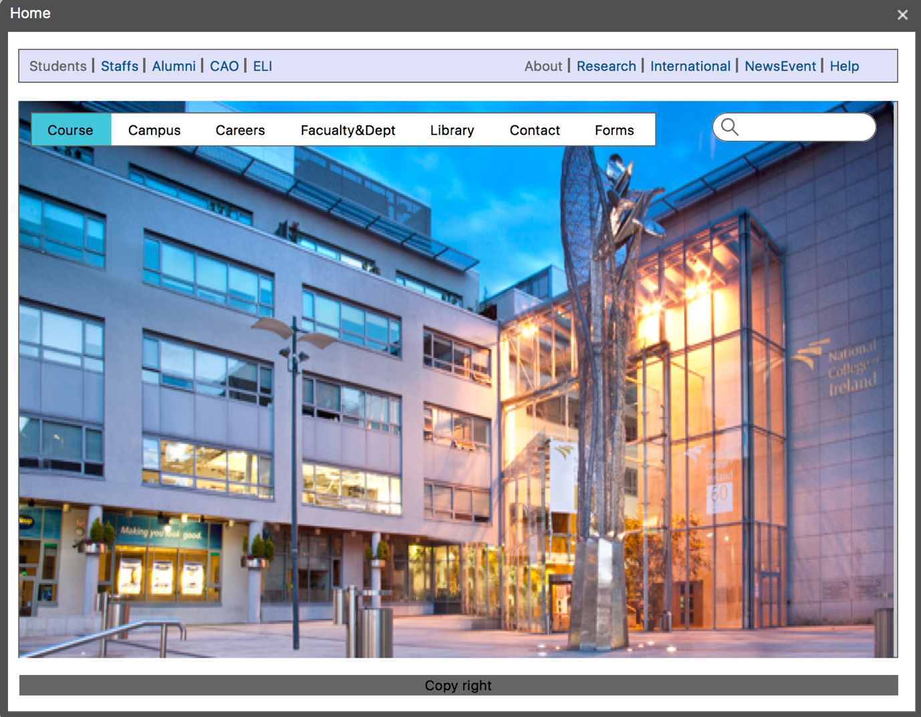

APPLICATIONS PAGE:

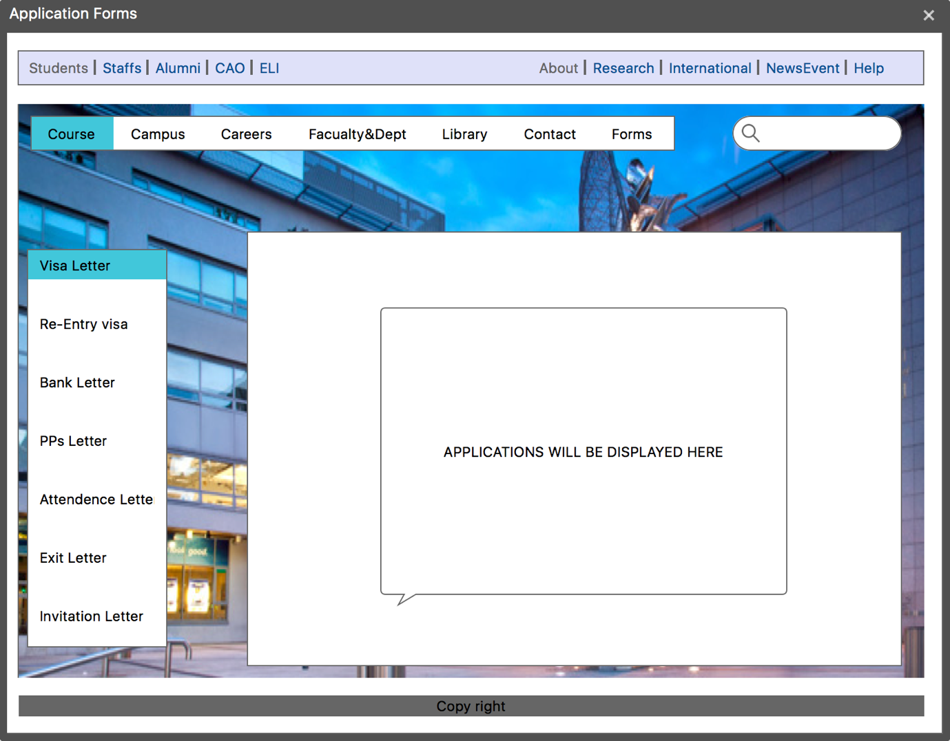

**CONTACT PAGE:**

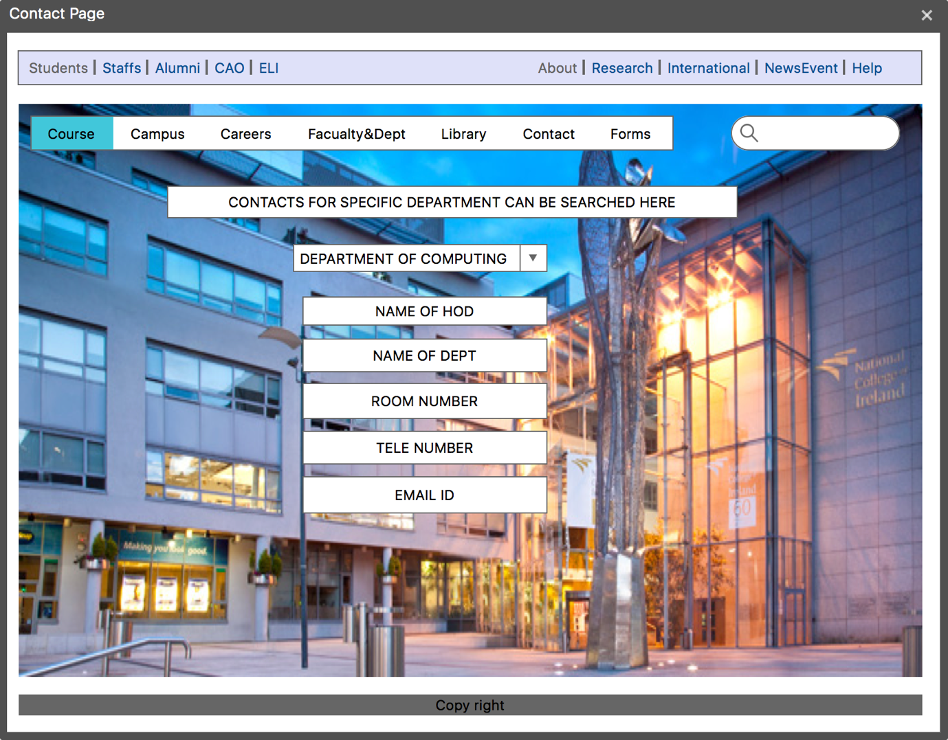

**ATTANDENCE PAGE:**

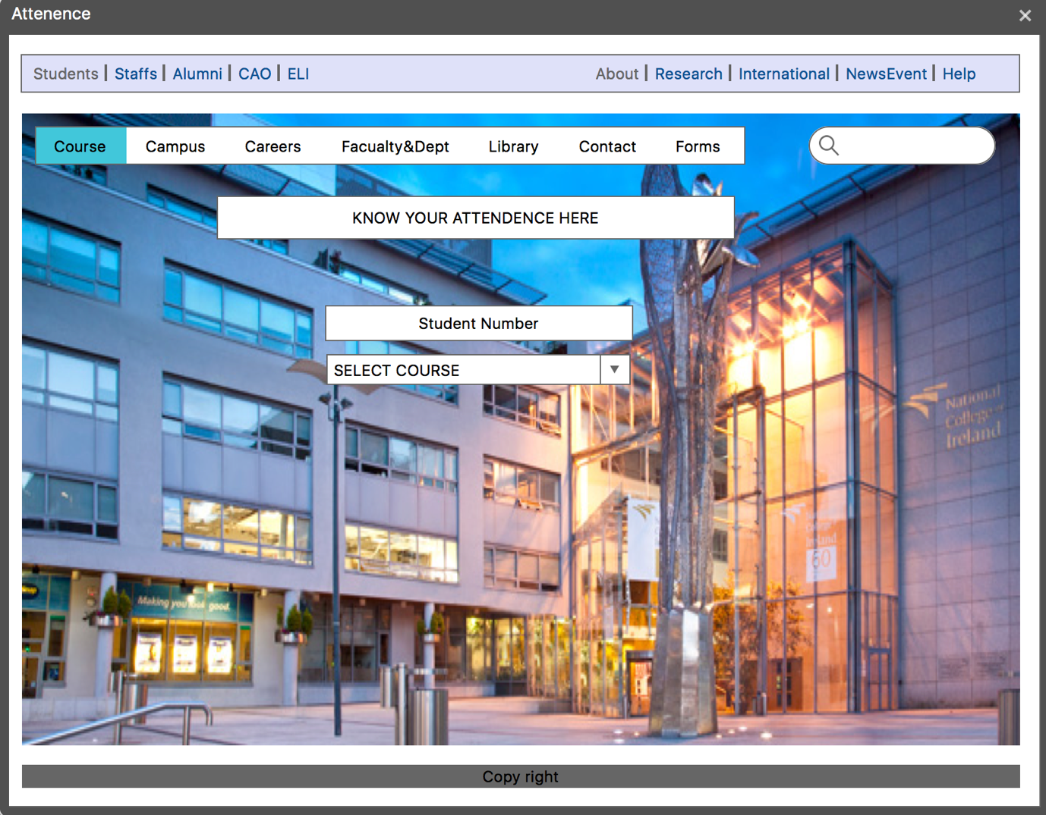

**OBSERVATION:**

After completing the Observation Session

During the observation and after the observation session it was obvious that there is a wide variety of issues with the current NCI website that needs to be changed in the re-design. During the post-observation interview was when I discovered the majority of the issues that people had with the particular NCI website design, however I also noticed things throughout the observation session.

First of all, many people complained that the NCI website wasn't very aesthetically appeasing, lacking a wide variety of videos relating to the colleges.

Another issue a lot of people had was in attempting to locate a particular part of the website, they appeared to have a very difficult time in attempting to locate specific parts. Something which I think everyone would agree is a priority aspect to address during the website redesign.

One thing I also noticed was that trying to access a specific timetable for a particular course was incredibly inconvenient. The student would have to first, find the timetable section of the website, choose their specific department in the college, find their program out of a list of many, select a week range, and then a time. This came across to me as being incredibly bad design and I think it needs to be changed in the upcoming redesign of the website.

One thing that I noticed was that when people were in need of information, there was no access to a live chat feature on the NCI website, I believe that this is important for the college to have as sometimes a student may need information instantly, in the case of missing an examination or even a project deadline due to a serious issue for example.

Possible Solutions

I believe that the new design of the NCI website should contain a wide variety of pictures and videos, showing off the college. Currently there are many videos of the students and alumni, however there isn't many showing off the interior and exterior of the college building. Something that would not only be aesthetically pleasing towards someone on the website, but also might entice someone to apply for the college on their CAO. A virtual tour could also be included allowing people to not only see particular pictures, but also the entire college, including the Mayor Square area, particular rooms, the student's union and maybe even some of the student accommodation.

In regards to the presentation of information, I believe that links to the majority of the site should be available on the main page of the NCI website, meaning that a student, staff, or even a visitor can find the information they need quick and efficiently, without too much effort.

I think that an easy solution to the timetable problem would be to put everyone's course timetable on their specific Moodle page, meaning that they would have a link to access their particular courses timetable for that week just one click away.